SALES ANALYSIS

Ifeoluwa Ogunmiluyi

This document contains the analysis result of the product and sales transaction from year 2018 to 2020. The analysis was carried out based on the following requirements:

1. Top six (6) states
2. Quarterly sales of the top three sates
3. Monthly sales of all states
4. Quarterly sales of all states
5. Top sales based on product

**DASHBOARD OVERVIEW:**

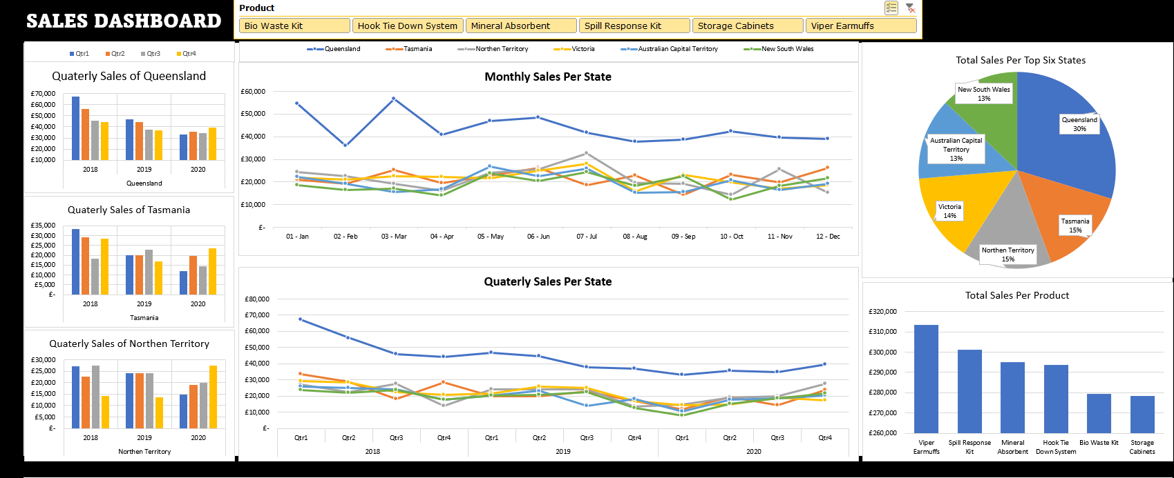

**Summary**: This is an overview of an interactive dashboard. It contains all above listed requirements with the inclusion of the product slicer in analyzing the changes in all charts with respect to the combination of one or more product.

**TOP SIX STATES:**

**Summary**: The chart of the top six states is represented in a pie chart with Queensland holding 30% of the total sales. Tasmania and Northern Territory both shares the same 15% as well as New South Wales and Australian Capital Territory both having 13% of the total sales. Victoria states has 14%.

**TOP THREE SALES QUARTERLY SALES:**

**Summary**: Queensland has the highest sales with a total of £ 522,699. Year 2018 first quarter recorded the highest in the space of the three years. There was a drop in sales for year 2018. A little increase in year 2019 first quarter before a decline till the third quarter in year 2020.

**Summary**: Tasmania recorded high sales in the first, second and fourth quarter of year 2018 but a significant decline in sales in 2019 and 2020. An increase year 2020 second quarter, followed by a decline and then a higher sales in the final quarter of year 2020.

**Summary**: Northern Territory recorded a high sales in year 2018 with a low record in the closing quarter, followed with a significant and static increase in the first three quarters od year 2019. There was a drop in the final quarter, but the sales had a massive increase in each quarter till the end of year 2020.

**MONTHLY SALES FOR ALL STATES:**

**Summary:** The chart above shows the sales recorded each month for the whole three years to know the pattern of sales in each period of the year. For the whole states, there was a drop in sales in February, followed with an increase in March for Queensland, Victoria, North South Wales, and Tasmania. From April till December had a fluctuating pattern for all states. However, all states closed with an increase in sales except Northern Territory.



**QUARTERLY SALES FOR ALL STATES:**



**Summary:** This chart shows the quarterly sales for each state. For the whole three year, Queensland had a continuous drop in sales with few spike in sales in 2019 first quarter and 2020 fourth quarter. The other five state sales performance looks constant has the year 2018 first quarter sales clearly align with the closing quarter in year 2020.

**TOP SALES PER PRODUCT:**

**Summary**: The bar chart shows the analysis of product sales. The Viper Earmuffs has the highest sales with Storage Cabinets having the lowest sales.